**1. RMI Vs CORBA**

|  |  |  |
| --- | --- | --- |
| **S.N** | **RMI** | **CORBA** |
| ***1*** | ***RMI is a Java-specific technology.*** | ***CORBA has implementation for many languages.*** |
| ***2*** | ***It uses Java interface for implementation.*** | ***It uses Interface Definition Language (IDL) to separate interface from implementation*** |
| ***3*** | ***RMI objects are garbage collected automatically*** | ***CORBA objects are not garbage collected because it is language independent and some languages like C++ does not support garbage collection*** |
| ***4*** | ***RMI programs can download new classes from remote JVM’s*** | ***CORBA does not support this code sharing mechanism*** |
| ***5*** | ***RMI passes objects by remote reference or by value*** | ***CORBA passes objects by reference*** |
| ***6*** | ***Java RMI is a server-centric model.*** | ***CORBA is a peer-to-peer system.*** |
| ***7*** | ***RMI uses the Java Remote Method Protocol as its underlying remoting protocol*** | ***CORBA use Internet Inter- ORB Protocol as its underlying remoting protocol.*** |
| ***8*** | ***The responsibility of locating an object implementation falls on JVM.*** | ***The responsibility of locating an object implementation falls on Object Adapter either Basic Object Adapter or Portable Object Adapter.*** |

# IDL (INTERFACE DEFINATION LANGUAGE)

***IDL in the context of Java often refers to the Interface Definition Language used in CORBA, particularly in the context of defining interfaces for remote objects in a distributed system. The Java IDL compiler helps bridge the gap between Java and other languages that support CORBA by generating Java interfaces from the IDL specifications.***

***Idl simple program***

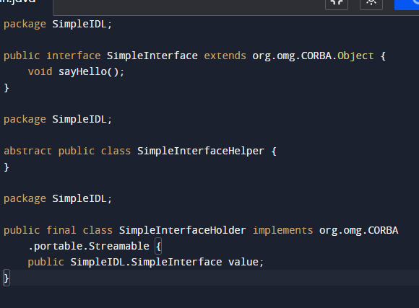

***CORBA:***

***CORBA stands for Common Object Request Broker Architecture. It is a middleware technology that enables communication between objects in a distributed computing environment. CORBA allows objects written in different programming languages and running on different platforms to communicate with each other as if they were part of a single application.* DIFFERENCE** BETWEEN CORBA AND IDL

|  |  |  |
| --- | --- | --- |
| **Feature** | **CORBA** | **IDL** |
| ***Purpose*** | ***Middleware technology for distributed computing*** | ***Specification language for defining interfaces*** |
| ***Main Components*** | ***Object Request Broker (ORB), IDL, other services*** | ***Language-neutral interface description language*** |
| ***Communication*** | ***Defines a protocol for communication between distributed objects*** | ***Describes interfaces, not involved in actual communication*** |
| ***Implementation*** | ***Defines the architecture for distributed object communication*** | ***Specifies the structure of interfaces*** |
| ***Use Case*** | ***Building distributed systems with distributed objects*** | ***Defining interfaces for communication in distributed systems*** |
| ***Interoperability*** | ***Enables interoperability between different languages and platforms*** | ***Facilitates interoperability between different languages*** |